Teaching and Learning Energy Transformations in the Context of Environmental Crisis

C.Stefanidou^{(a)}, K.Tampakis^{(α)}, D.Stavrou^{(b)}, C.Skordoulis^{(a)}
^{(a)} Department of Primary Education, University of Athens
^{(b)} Department of Primary Education, University of Crete
sconstant@primedu.uoa.gr , konstantinos.tampakis@gmail.com , dstavrou@edc.uoc.gr, kostas4skordoulis@gmail.com

Abstract. In this paper, we present a research aimed at recognizing the teaching and learning procedures of pre-service teachers regarding experimental apparatus that use two exemplary renewable and low impact energy sources, the photovoltaic and the hydrogen cell. In order to collect the data, experimental interviews, the so called “teaching experiment” were used. The interviews lasted three hours and consisted of the serial presentation and discussion of the photovoltaic experiment, the fuel cell experiment and the combinatory experiment. Data was analyzed using qualitative content analysis methods. Results show that most students were able to give adequate answers concerning the energy conversions that take place in the photovoltaic cell and in the fuel cell.

Keywords. Energy transformation, energy cell, photovoltaic, pre-service teachers

1. Introduction

In recent years, interest about environmental issues in science education has been rising steadily. Arguably the most central of current environmental problems is the energy crisis, which is related with both fossil fuel use and the resulting pollution. One of the many consequences of electrical energy generation through conventional means is the creation of greenhouse gases. For that reason, environmental research has been focused on using renewable and low impact energy sources. In this paper, we present a research aimed at recognizing the teaching and learning procedures of pre-service teachers regarding experimental apparatus that use two exemplary renewable and low impact energy sources, the photovoltaic and the hydrogen cell.

2. The study

The study carried out at the Department of Primary Education, at the University of Athens. In order to collect the data, experimental interviews, the so called “teaching experiment”, were used. The teaching experiment was designed for the purpose of eliminating the separation between the practice of research and the practice of teaching [3]. It may be viewed as a Piagetian critical interview that is deliberately employed as a teaching and learning situation. The teaching experiment method setting has proven a powerful means to investigate the development of students’ conceptions towards the science points of view [1]. The interviewer assumes the roles of a “classical” interviewer, who tries to understand students’ individual conceptions, and a teacher, who must have answers to students’ conceptions and make the appropriate intervention at just the right moment [2].
The sample group consisted of 23 pre-service teachers, separated in 7 teams of 3 persons each and 1 team of 2 persons. The interviews lasted three hours and consisted of the serial presentation and discussion of the photovoltaic experiment, the fuel cell experiment and the combinatory experiment. The interviews were videotaped, transcribed and evaluated according to qualitative content analysis methods [4].

3. The experiments

During the interviews three experiments were carried out.
1st Experiment - Photovoltaic Experiment: The arrangement includes a photovoltaic, a voltmeter, a small plastic car with an electric motor installed and an incandescent light bulb which substitutes the sun light for the experimental needs. In Photo 1 the photovoltaic which is placed in front of the light bulb is connected to the voltmeter, giving an evident calibration. Afterwards, in Photo 2, the photovoltaic is connected to the small car.
The photovoltaic transforms solar energy to electrical energy. The electric motor of the plastic car converts electric energy into kinetic. Finally, the kinetic energy degrades to heat due to the work of friction.
The students ascertain the conversion of solar energy into electric, its use in moving a small car and its degradation into heat.

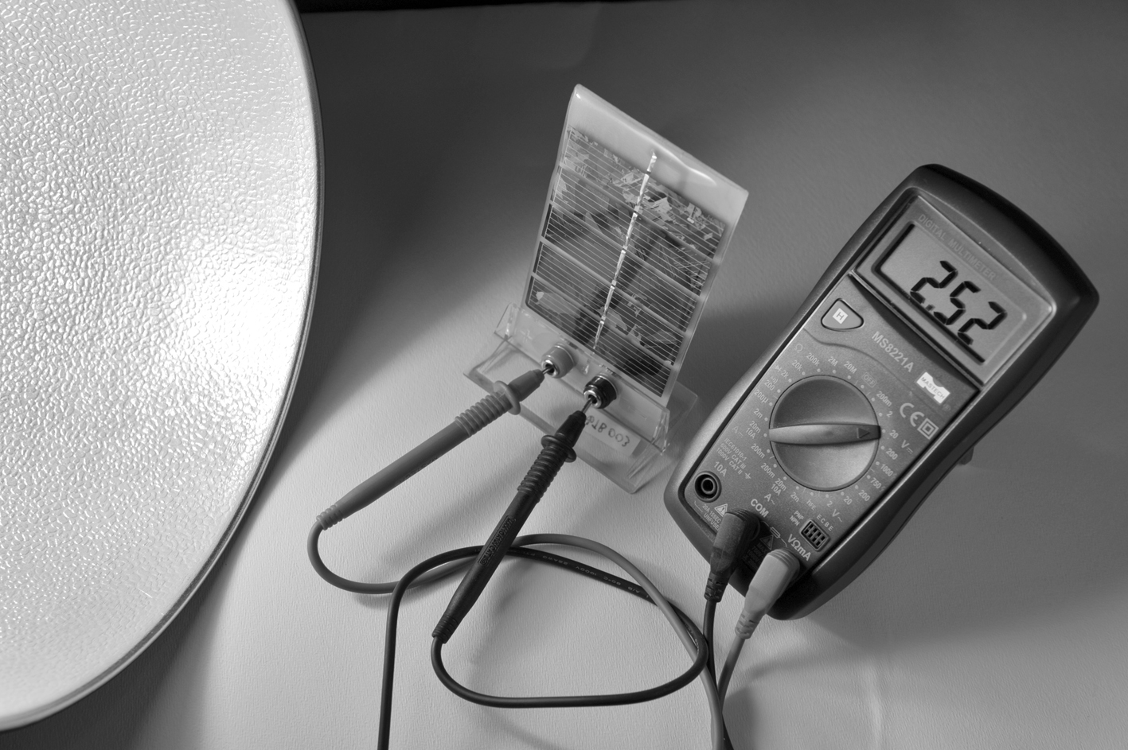

Photo 1: Photovoltaic – Voltmeter

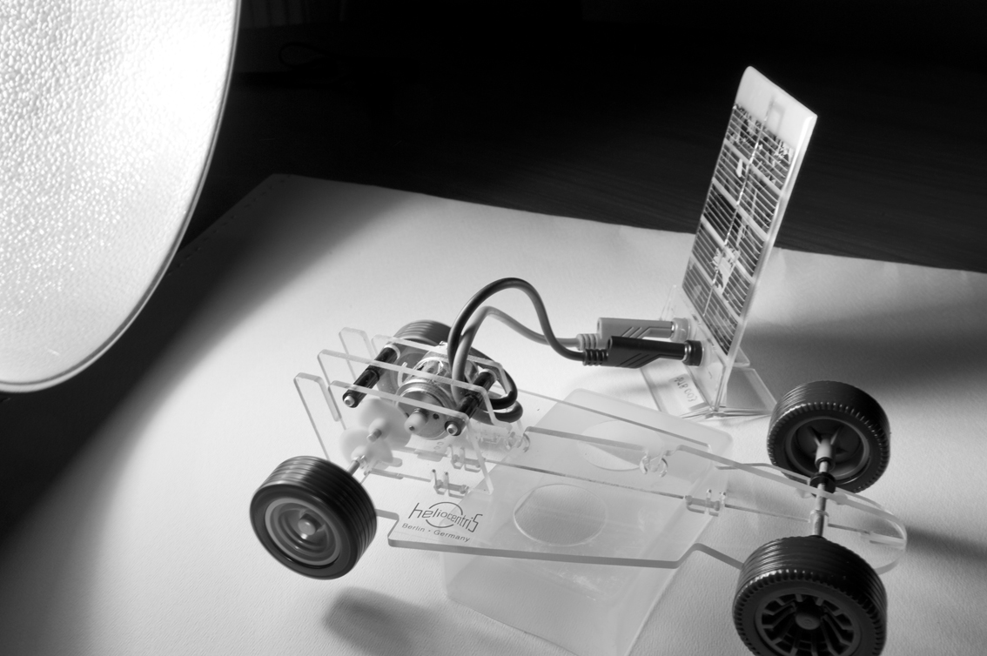

Photo 2: Photovoltaic – Small plastic car

2nd Experiment - Hydrogen cell: The arrangement includes an hydrogen cell, a battery, a voltmeter, and a small plastic car with an electric motor installed. First, electrolysis is carried out in the hydrogen cell, using the battery and afterwards the cell is connected to the small car (Photo 3).
The students ascertain the conversion of stored chemical energy created from electrolysis to electric and subsequently kinetic energy. Finally, friction produces heat.

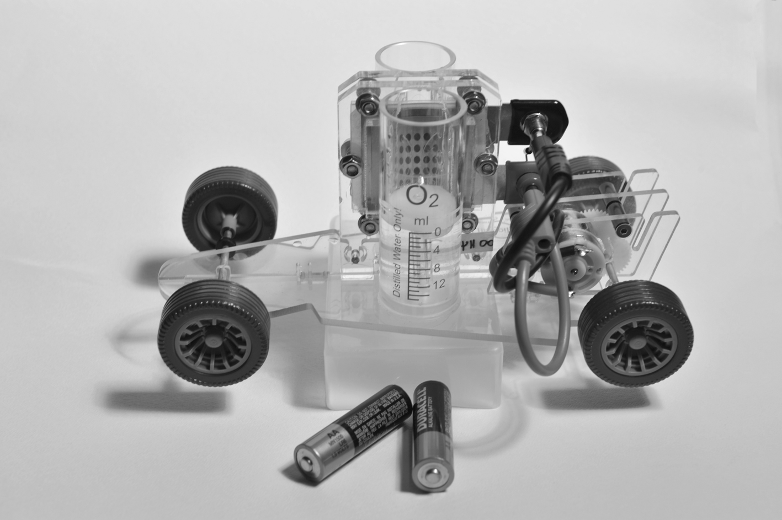

Photo 3: Fuel cell – Battery - Small plastic car

3rd Experiment - Photovoltaic and Hydrogen cell: The arrangement is a combination of the two previous arrangements. In this experiment, the energy source for the electrolysis is the photovoltaic cell, bypassing the need for a conventional energy source (battery) (Photo 4). In this experiment, the fuel cell is used as an energy storage apparatus providing an autonomous system of producing electric energy out of renewable and low impact forms of energy.
Students observe the energy transformations that occur.

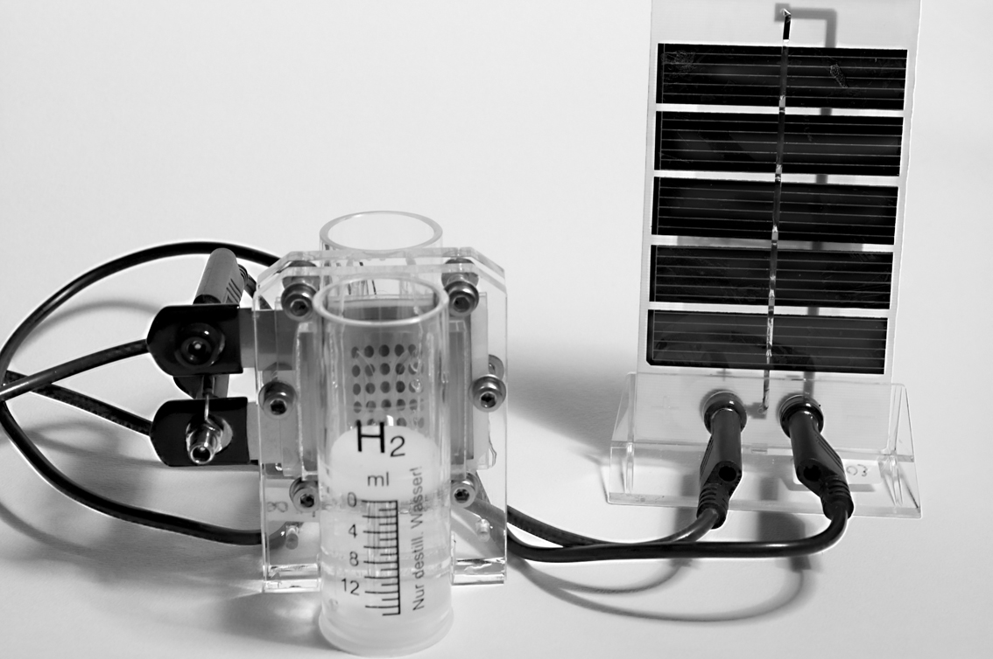

Photo 4: Photovoltaic – Fuel cell

4. Outline of the teaching experiment

The teaching experiment setting aims to investigate the development of students’ conceptions towards the science point of view [1]. In this context, we have designed the partially structured interview that follows in order to reveal some of the students’ views and learning difficulties as well. A brief outline of the teaching experiment [2] is presented below
- Introduction to energy crisis – Arising need for renewable and low impact forms of energy
- Description of the arrangement
- Expectations and predictions of the outcome of the experiment
- Run of the experiment
- First explanation of energy transformations
- Detailed analysis of the procedure.
- Emphasis on the role of the arrangement in energy conversion and degradation.
- Students formulate the experiment conclusion.
- Students formulate an overall conclusion for energy conversion and degradation.

5. Results

The data analysis demonstrated that the majority of the students at the end of the interview could give satisfactory explanations of energy transformations, conservation and degradation. Some of the students’ conceptions very often reported are mentioned below:
- Confusion between solar water heater and photovoltaic
- Notion that the photovoltaic stores solar energy somehow
- Notions concerning the conservation or energy (Energy degradation as opposed to energy conservation – Energy degradation as energy transferred to a different place) [5].
- Confusion between energy and force
Regarding the confusion between solar water heater and photovoltaic, sometimes it was a matter of apparatus while sometimes it was a matter of the operation mode. The learning difficulty was surpassed by using both the voltmeter and examples from everyday life. The notion that the photovoltaic stores energy was dealt by turning the lump off. When the lump was off the calibration of the voltmeter, which was connected to the photovoltaic, was almost instantly zeroed.
There were several approaches to energy conservation, energy conversions and degradation by the students. Some of the students’ notions about energy conservation can be characterised as inconsistent. They know that the energy should be conserved but often doubt it. For example:
P: We know that energy does not disappear. It converts from one form to another. Maybe, the kinetic energy of the wheels was converted into heat.
Teacher: Good. Through which procedure?
P: Frictions?
Teacher: Where does friction appear?
P: in the air… and… while the wheels are moving … perhaps the energy that passes to the environment disappears…
Such a difficulty was treated using examples that students had from their everyday experiences. For example, the produced heat by hands rubbing.
Some of the students associate the degradation of energy with the replacement of energy to another place, often an unknown one. For example:
Teacher: When the light is on, the wheels are moving. What happens when I turn the light off?
I: I believe that something happened within the photovoltaic…
A: In any case, it did not disappear.
I: Was it stored in the photovoltaic?
C: For sure, it has left the wheels and it has gone somewhere…in the atmosphere or it became another form of energy…
There is a remarkable number of students giving right answers yet offering an explanation in the framework of everyday experiences and not in the framework of energy conservation [6].
The everyday way of thinking coexists with the scientific one. Emphasis is given according to the context.
Therefore, we do not aim at replacing an idea with a new one but at the conceptual evolution of the existing idea according to the context. Thus, we do not expect the teacher training materials presented here to be able to replace teachers’ everyday language but rather to make teachers aware of the educational risk of using the everyday language in the school context [7].

6. Conclusions

In this paper we have attempted to figure out some of the teaching and learning procedures of pre-service teachers, in the context of environmental crisis. The study illustrates that, at the end of the interview, students could give some satisfactory descriptions and explanations regarding the energy tranformations that happen in the photovoltaic and fuel cell. Moreover, students become more conscious about the development of their conceptions towards the scientific point of view.
It is worth mentioning that some difficulties seem to persist, despite students formulating the proper energy conversions, In any case, students express their gratification for participating in the interview, recognizing its role in their future science teaching:
Κ: However, these are things that we have been hearing about for years, but never had the chance to see them. At least, we now know something about low impact and renewable energy sources…

7. References (and Notes)

[1] Komorek M, Duit R. The teaching experiment as a powerful method to develop and evaluate teaching and learning sequences in the domain of non-linear systems. International Journal of Science Education 2004; 26(5): 619-633.

[2] Stavrou D, Duit R, Komorek M. A teaching and learning sequence about the interplay of chance and determinism in nonlinear systems. Physics Education 2008; 43(4): 417-422.

[3] Steffe L, Thompson P. Teaching Experiment Methodology: Underlying Principles and Essentials Elements. Research design in mathematics and science education In R.Lesh and A.E.Kelly Eds. Hillsdale, NJ:Erlbaum, 2000.

[4] Mayring P. Qualitative Content Analysis.
Forum: Qualitative Social Research 2000;
1(2): Art.20

[5] Kruger C. Some primary teachers’ ideas about energy. Physics Education 1990; 25:86-91

[6] Duit R. Students’ Notions About the Energy Concept – Before and After Physics Instruction. In: ERIC eds. Proceedings of the Conference on “Problems Concerning Students’ Represantation of Physics and Chemistry Knowledge”; 1981 Sept 14-16 Ludwigsburg, West Germany, University of Ludwigsburg; 1981.p.53.

[7] Pinto R, Couso D, Gutierrez R. Using Research on Teachers’ Transformations of Innovations to Inform Teacher Education. The Case of Energy Degradation. Science Education 2004; 89:38-55

