Constantine Skordoulis, Gianna Katsiampoura, “Teaching experiments in 18th-19th century Greek physics textbooks”, Archives Internationales d’Histoire des Sciences, vol. 60, 2010, pp. 79-92

The research leading to these results received financial support from the European Union’s Seventh Framework Program [FP7/2007-2013] under grant agreement no 229825
TEACHING EXPERIMENTS IN 18th – 19th CENTURY
GREEK PHYSICS TEXTBOOKS

Constantine Skordoulis & Gianna Katsiampoura
Department of Education, University of Athens, Greece

Introduction
During the late 18th and early 19th centuries a number of Physics textbooks were published by Greek scholars aiming in the education of citizens living in what is now mainland Greece and in communities in what was then the Ottoman and Austro-Hungarian empires (Karas 2009).
There was a manifold of reasons for the publication of these textbooks. The new class of Greek merchants that developed mainly in diaspora had to be educated in the “new scientific spirit” so as to be in balance with its European counterparts. Furthermore, radical intellectuals inspired by the Enlightenment appealed to science education as a vehicle that would lead to the liberation of a people living under Ottoman imperial rule. In the recent years, some scholars have even coined the term “Neo-Hellenic Enlightenment” (Demaras 1977) in order to identify the introduction and adaptation of the ideas of the Scientific Revolution in the Greek intellectual space. It is beyond doubt that the new Science with its foundation on experimental method was bringing a decisive break with scholasticism and metaphysical superstition associated with clerical and feudal rule (Iliou 1975, Dialetis et al. 1997). It has to be emphasized that the new scientific spirit was introduced in the Greek speaking communities in connection with the radical political ideas influenced by the European Enlightenment and the French Revolution (Kitromilides 1978, 1990).
Our recent research has shown that in a number of schools flourished in certain parts of the Greek mainland and in the communities of the diaspora there were organized science teaching laboratories and that demonstration experiments formed an integral part of Physics teaching (Institute of Neohellenic Research 1997, 2003).
Although the performance of the experiment and the role of the experiment in the teaching process was in most cases the sole responsibility of the teacher and to a lesser degree of the curriculum that has been approved by the Board of each school, the contribution of the textbook cannot be considered negligible.
The role of the textbook acquires more importance in schools where there were not organized laboratories and the students were taught about the experiments solely by reading the textbooks.
Our paper is organized as following: In the first chapter, we give an account of the educational institutions in mainland Greece and in diaspora where the new experimental method was introduced in Physics instruction and also of the teachers that introduced the new curricula.
In the second chapter, we classify the published Physics textbooks and we analyze the experiments described in five of the most widely used textbooks published in the period between 1766 -1812 in Vienna, Leipzig and Venice. Our analysis is based on a thematic classification of the experiments described therein with emphasis on what we term as “Historical Experiments” (ie. Experiments performed by famous scientists of the period of interest) and of the references to scientific instruments and apparatuses contained in the textbooks.
Finally, in the third chapter we discuss the didactical use of the experiments and its importance in educating the population in a new way of thinking paving the way for the course of national liberation that is to follow.

1.Schools and Teachers
The teaching experiment became part of education in Physics during the second half of the 18th century and during the first decades of the 19th century in various schools belonging to the Greek speaking communities in the Danubian counties of the Ottoman Empire and in various other schools in what is now mainland Greece and Asia Minor.
In this section we give an account of the schools and the teachers that introduced the new experimental method in the teaching of Physics in the curricula of these schools.
The first school that introduced physics courses based on the new experimental method was Athonias School in the monastic community of the Holy Mountain Athos (Aggelou 2000). This school was founded in 1750 and in 1753, when Eugenios Voulgaris was appointed as the Director, the school started to flourish becoming a pole of attraction not only for students that intended to pursue clerical studies but also for others seeking a higher education with the total number amounting to over 200 in some cases. Voulgaris was a very experienced teacher and introduced a curriculum that gave special emphasis on mathematics, physics and cosmography based on the experimental methodology. His teaching notes compiled in the form of a manuscript formed the basis of his textbook that was published later in 1805 in Vienna. In 1759, Voulgaris was forced to leave the directorship of the school after severe disagreements over the content of his teaching. Gradually, the school loses its fame and is closed in the first decade of the 19th century.
In 1780 in the Academy of Bucharest (Camariano-Cioran 1974), Konstantinos Vardalachos was a senior teacher teaching Philosophy, Mathematics and Experimental Physics. He reorganized the school promoting natural sciences as the main teaching subject introducing instruments of physics and chemistry in the instruction. Research has shown that every Saturday one hour was devoted to the laboratory exercise of the students.
In the Hegemonic Academy of Iasi, in what is now Romania (Camariano-Cioran 1974) teaching experiments were performed by I. Mesiodax and Niciforos Theotokis. As a headmaster, Theotokis reorganized the academy around the middle of 1760. In his second period in office (1774) he came in conflict with conservative cycles of the city due to his insistence in teaching the “new philosophy” and he was forced to leave the school.
In the Kaplaneios School of Ioannina in north western Greece the “experimental Physics” of Vardalachos is taught by Christoforos Filitas and Athanasios Psalidas (1797-1820). The latter prepares his own “General Physics” teaching notes based on Horvath’s “Physica Generalis”.
In the Patriarchal Academy of Constantinople, the headmasters D. Proios (1804-1807), St. Dougkas (1809-1810) and Konstantinos Koumas (1814-15) teach experimental Physics and perform experiments during lectures.
The Academy of Kydonies (in what is now called Aivalik in Asia Minor) is founded in 1790. From 1800 up to 1821 two well-known scientific figures act as directors: Benjamin Lesvios (1800-1812) and Theofilos Kairis (1812-1821). Both of them have written textbooks on Physics, which they teach during their time of service. Teaching experiments are performed since 1796.
A course on experimental Physics with experiments is taught in the school of the island of Chios, which is founded in 1815. In 1816, K. Vardalachos was appointed there as a teacher.
The “Gymnasium of Sciences” (Iliou 1975) is founded in the city of Smyrna (what is now called Izmir in the mainland of Asia Minor in what now is Turkey) in 1808 with Konstantinos Koumas as its director. The school has been connected with the developing merchant class of the city. In 1810, it changed its name in “Philological Gymnasium” in contrast to the “Evangelic School” and organized experiments in physics and science laboratories. Experiments are performed in public for the audience other than the students of the school. In 1819, the school was attacked and partly destroyed by opponents of the experimental method.
In 1814, the school of Milies in Pilion (the home mountain of the centaurs according to the mythology) is founded. There are reports that experimental physics and Chemistry were taught.
A year before, in 1813, the Greek community of Zenum, a city then belonging to the Austro-Hangurian Empire (near Beograd of what is now Serbia) founded a school where Demitrios Darvaris introduced the teaching of experimental physics.
In the school of Ambelakia in Thessaly, Stefanos Dougkas donated a number of scientific instruments with the plan for establishing a Higher Education Institution. This project was not achieved due to the political developments and shortage of funds.
Until now we do not posses concrete information about the exact curricula of these schools concerning the physical sciences. It seems that the teacher appointed was following his own syllabus. What we know is that physical sciences were taught 6-8 hours weekly in the schools of Bucharest and Iasi, 5-6 hours weekly in Kydonies and Ioannina, 3-4 weekly in Constantinople etc.

2.The Textbooks and the Authors
During the period of late 18th early 19th centuries, a large number of textbooks were published. Karas (2009) in his research estimates the number of printed textbooks to over 200 while a number of others were discovered in the form of manuscripts in various libraries across Greece.
In our research, we examine the Physics textbooks published in this period. Except of these textbooks we have the textbooks of Astronomy, Chemistry, Geography, Botany/Natural History and a very large number of Mathematics textbooks.
We can distinguish three types of textbooks: i) translations of textbooks of European authors ii) textbooks based to a large extend on similar textbooks of European authors and iii) textbooks exclusively written by Greek authors sometimes comprising of their teaching notes.
The first category of textbooks includes:
- Benjamin Martin (Grammatica delle Scienze Filosofiche, published in Venice 1795) translated by Anthimos Gazis and published in Vienna (1799),
- Johann Heinrich Helmuth (Volksnaturlehre zur Dampfung des Aberglaubens, 6th edition published in Venice 1810) translated with the editorial assistance of Spyridon Vlantis and published in Venice (1810)
In the second category (i.e. textbooks published by Greek authors based on other textbooks published in Europe) we have:
- Niciforos Theotokis: Elements of Physics, in two volumes published in Leipzig 1766 and 1767. This textbook is based to a very large extend on Abbe Nollet’s Lezioni di Fisica Sperimentalle (Venice 1747) and Pieter van Mussshenbroeck’s Elementae Physicae (Naples 1751).
- Eugenios Voulgaris: Philosophers’ Favourites (Vienna 1805), which is also based on Peter, van Musshenbroeck’s Elementae Physicae (Naples 1751).
- Rigas Velestinlis: Physics Selections (Vienna 1790) based on the Encyclopedie published in Paris 1751-65 and Geneva 1778-1779.
- Konstantinos Koumas: Elementary Treatise on Mathematics and Physics (Vienna 1807) is based on Jean Claude Fontaine Cours encyclopedique et elementaire de Mathematique et de Physique (Vienna 1800).
The third category comprises of textbooks written exclusively by Greek authors that sometimes are collections of their teaching notes from the lectures in the schools where the authors have served. In this group we have selected the textbooks of three prominent teachers that were using the new experimental method in their course of teaching:
- Konstantinos Koumas, Synopsis of Physics published in Vienna (1812)
- Konstantinos Vardalachos, Experimental Physics, published in Vienna (1812) and
- Demetrius Darvaris Physics (3 Volumes) published also in Vienna (1812).

2.1.Teaching Experiments in the textbooks
a. Thematic Classification
We have chosen two textbooks from the second category and the three mentioned in the third and we proceed to a thematic classification of the experiments described therein. The results are shown in Table1 and are similar to those of Xenakis (2003). The numbers in the columns show the number of experiments described or suggested in each thematic group.

Textbooks | Mechanics | Properties of Gases | Properties of Liquids | Waves,  Acoustics  Optics | Heat | Electricity  and Magnetism
Theotokis – 1766 | 32 | 12 | 22 | 13 | 15 | 4
Voulgaris - 1805 | 20 | 5 | 16 | 10 | 10 | 16
Koumas -1812 | 22 | 25 | 31 | 27 | 20 | 50
Vardalachos-1812 | 11 | 5 | 8 | 5 | 19 | 19
Darvaris-1812 | 7 | 8 | 3 | 7 | 9 | 13

In the mechanics section the most common experiments described have to do with the study of the pendulum, the free fall in the presence of air or in vacuum, the motion in an inclined plane, the study of friction, the study of the momentum and the various forms of impact (elastic, plastic) between spheres.
There are also experiments to demonstrate the view that the elements are the undecomposable constituents of material bodies and that the elements were ultimately composed of particles of various sorts and sizes which cannot be resolved in any known way.
In the properties of gases and liquids (fluid mechanics) sections there are experiments concerning atmospheric pressure, cohesion forces, the shape of the surface of the liquids in a vessel, the laws of flux, elasticity and incompressibility of fluids.
In the Acoustics and Optics section there are experiments about the nature and properties of sound, analysis and synthesis of white light and also experiments in geometrical optics with lenses and mirrors.
In the section about Heat most of the experiments concern expansion and contraction, determination of the boiling point of various substances, melting and freezing and conduction of heat.
Finally, in the electricity and magnetism section there are experiments on magnetization by induction, demonstration of the magnetic field, electrification by friction, charging and discharging of a capacitor (“Leyden jar”), electrolysis, detection of atmospheric electricity, animal electricity, construction of a voltaic pile etc.

b. Historical Experiments
A very interesting feature of the textbooks is the extensive reference to experiments that are considered as landmarks in the development of modern physics that were performed by famous physicists of those days.
In the following section we give an indicative account of the historical experiments described in the textbooks considered.
In the Mechanics section there are descriptions of the free fall experiments by Pieter van Musschenbroek (1692-1761), Marin Mersenne (1588-1648), Giovanni Poleni (1683 -1761) and Giambattista Riccioli (1598 – 1671). There are also references to the free fall experiments by Galileo and Newton.
In the pages of the textbooks someone can also be informed about the experiments on friction by John Theophilus Desaguliers (1683-1744) and Pieter van Musschenbroek, the experiments on the constitution of matter by Anton van Levenhook (1632-1723) and Johann Christophorus Sturm (1635-1703) advancing the corpuscular theories and also the experiments by Willem Jacob Gravesand (1688-1742), G. Poleni and G. Riccioli in order to prove that the kinetic energy is proportional to u².
In the Properties of Liquids and Gases sections extensive descriptions are given to the experiments of Robert Boyle (1627-1691), Evangelista Torricelli (1608-1647) and Daniel Bernoulli (1700-1782) about the weight of the atmosphere, the experimental demonstration of the laws of flux, the dependence of hydrostatic pressure on the height of the liquid inside the vessel etc. There are also descriptions of the experiments of Blaise Pascal (1623-1682) (dependance of pressure on altitude), G. Poleni (the speed that a liquid flows from the bottom of the vessel depends on the friction between the liquid and the vessel walls), Jean Senebier (1742-1809) on the elasticity of water, Otto von Guericke (1602-1686) (Magdenbourg hemispheres), Edme Mariotte (1620-1684) (the quantity of liquid that flows from the vessel depends on the height of liquid in the vessel) Jean Picard (1620-1682) (flows are proportional to the area of the base of the vessel) etc.
Extensive reference is also made to the experiments performed in the Academy of Florence. From the ancient figures there are references to the works of Archimedes especially his Screw and his method to determine the percentage of gold in the crown of the king of Syracuse and of the findings of Sextus Julius Frontinus (40-103 AD).
In the Optics section there is extensive reference to Newton’s experiment for the analysis and synthesis of the white light, Newton’s rings, on Christian Wolff’s (1679-1754) observations of the human blood with a microscope, on the absorption of solar rays by cloths of different colours (Benjamin Franklin 1706-1790) and also of William Herschel’s (1738-1822) experiment to prove that light and thermogono are of different nature.
In the section of Heat there is an account of Fahrenheit’s (1686-1736) experiments for the calibration of various types of thermometers, the experiments in the academy of Florence (when the water freezes then its volume increases and the dependence of the freezing point on pressure), Musschenbroek’s experiment on the linear expansion of a metal rod when heated, and Alessandro Volta’s (1745-1827) experiment on water cooling and water freezing during evaporation.
In the Electricity and Magnetism section there are references to Musschenbroek’s technique for creating new magnets by cutting the parent magnet, Abbe Nollet’s (1700-1770) experiment on electricity and the human body and on capacitor charging by an electrical machine, the electric discharge by Ludolf of Berlin (1744), experiments on electrification by induction by William Gilbert (1544-1603) and Grey, the experiment of the magic “horseshoe” by Benjamin Franklin and also his experiment for the detection of the electricity of the atmosphere.
The electrolysis of Potassium, Sodium, Barium, Calcium and Magnesium as discovered by Sir Humphry Davy (1807) is also presented. There is also extensive reference to the works of Luigi Galvani (1737-1798) (animal electricity) and Volta (circuits with battery).
The reference to experiments of these famous scientists serve a dual purpose. On the one hand the reference of the name of the scientist acts as a means of persuading the students for the validity of the theory presented while at the same time the European experimental tradition is transferred to the Greek speaking regions and the literate population is getting acquainted with the European experimental tradition. The reception of this tradition in the Greek speaking communities had a very important social and cultural impact mainly through educating the upper middle classes to a new way of thinking (Henderson 1971). It’s for this reason that in many cases the experimental methodology caused reactions not only from the side of the official church but also from the group of teachers sided with the Aristotelian tradition and/or other conservative members of the wider community.

c. The Instruments
In the textbooks’ pages where the experiments are described there are references and descriptions of various instruments either as part of the experimental apparatuses or as stand-alone devices. The most common instruments mentioned in the textbooks are: Electrostatic generators and various accessories for the conduction of experiments in electricity, batteries (voltaic elements), Electrometers and electrostatic capacitors (Leyden Jars), Vacuum pumps (pneumatic) for the performance of experiments in aerostatics, Microscopes and systems of lenses and mirrors for the conduction of experiments in optics, Thermometers along with glass tubes, glass vessels, flasks and valves for the conduction of experiments in Heat and finally Chronometers, inclined planes and various types of pendulums for the conduction of experiments in Mechanics.
In some cases there are pictures (etchings – gravures) in the last pages of the textbook where pictures of the instruments described in the textbook are shown.
Some of these pictures are shown below.
In Figure 1 we show a page from K. Vardalachos’ Experimental Physics (Vienna 1812).
-----PLACE Figure 1 ABOUT HERE------
In Figure 2 we have a picture from Voulgaris, Philosophers’ Favourites (Vienna 1805)
----- PLACE Figure 2 ABOUT HERE------
In Figure 3 we show a picture from Darvaris, Physics (Vienna 1812)
----- PLACE Figure 3 ABOUT HERE------
Figure 4 is from Koumas, Synopsis of Physics (Vienna 1812)
----- PLACE Figure 4 ABOUT HERE------

3.Didactical Approach
Experimental apparatuses and instruments were bought by rich merchants in Western Europe and were donated to the schools of the Greek speaking communities. Due to the high cost there was a possibility only for a single experimental apparatus for each kind of experiment to be installed in a school.
This is most probably one of the reasons that most of the experiments described in the textbooks are demonstration experiments. They are designed to be performed by the teacher in front of the students having as a sole purpose the verification of a theory that has been exhibited in the previous pages.
Students are sole observers and not experimenters.
What is also missing in these experiments is the process of “measurement”. In very rare occasions there are experiments in the textbooks urging students to take measurements and draw tables of measurements in order to deduce a physical law. In very few cases tables of measurements are given in the textbooks and students are asked to work on them.
The absence of “measurement” has the negative effect that students are not trained in the mathematical processing of their findings (the quantification of the observation) missing the most important feature of the new methodology introduced by the Scientific Revolution: the connection in the last analysis of the experiment with mathematics.
Another feature of the textbooks considered is that there are no pictures and drawings of all the apparatuses or of the experimental set ups described in the textbooks. There are some drawings in the last pages of the textbooks for some instruments or experimental set ups but the majority of experiments described are more or less “thought experiments”. The students when reading the textbook have to use their imagination in order to construct a mental representation of the experimental set up. This is where the role of the teacher becomes indispensable. The teacher had a central role in producing additional material in the form of pictures or drawings in order to facilitate students’ understanding of the experiment.
However, one has to take in account that these textbooks were used in schools having various instruments in their possession and in some cases organized laboratories and therefore instruments mentioned in the textbooks could be easily identified by the students with the aid of the teacher.
Despite, the difficulties and the drawbacks mentioned one has to appreciate the contribution of the new experimental methodology in altering the Aristotelian thinking style among the educated population of the Greek speaking communities. Such a process of change was not at all easy given the strong affiliation to the “glorious past” of classical antiquity and to the “ancestors”.
The introduction of the new mode of thinking was a necessary precondition for the connection of the national aspirations of the new Greek middle class with the Enlightenment project.

REFERENCES

Aggelou A. (2000), Illumination, Hermes, Athens (in Greek).

Camariano-Cioran A. (1974), Les Academies princieres de Bucarest ed de Jassy et leurs professeurs, Thessaloniki.

Demaras C.Th. (1977), Neohellenic Enlightenment, Hermes, 2nd ed. Athens (in Greek).

Dialetis D., Gavroglou C., Patiniotis M. (1997), “The sciences in the Greek speaking regions during the 17th and 18th centuries”, Archimedes, vol. 2.

Henderson G.P. (1971), The revival of Greek Thought 1620-1830, Scottish Academic Press, London-Edinburgh.

Iliou Filippos (1975), “Luttes socials et movement des Lumières à Smyrne en 1819”, Structure sociale et dévéloppement culturel des villes sud-est européennes et adriatiques aux XVIIe-XVIIIe siècles, Association Internationale d’Études du Sud-Est Européen, Bucarest.

Institute of Neohellenic Research/National Hellenic Research Foundation (1997), The sciences in Greek space, Trochalia, Athens (in Greek).

Institute of Neohellenic Research/National Hellenic Research Foundation (2003), History and Philosophy of Sciences in Hellenic space (17th-19th centuries), Metaichmio, Athens (in Greek).

Karas G. (2009), The adventures of Neohellenic Sciences, Hellenic Physical Society, 2nd edition Athens (in Greek).

Kitromelides P.M. (1978), Tradition, Enlightenment and Revolution, PhD Dissertation, Harvard University.

Kitromelides P.M. (1990), “The idea of science in the modern Greek Enlightenment”, Nicolakopoulos P. (ed.), Greek Studies in the Philosophy and History of Science, Kluwer Academic Publishers, Dordrecht.

Xenakis Ch.Th., “The experiment”, in Institute of Neohellenic Research/National Hellenic Research Foundation (2003), History and Philosophy of Sciences in Hellenic space (17th-19th centuries), Metaichmio, Athens (in Greek).
Figure 1.

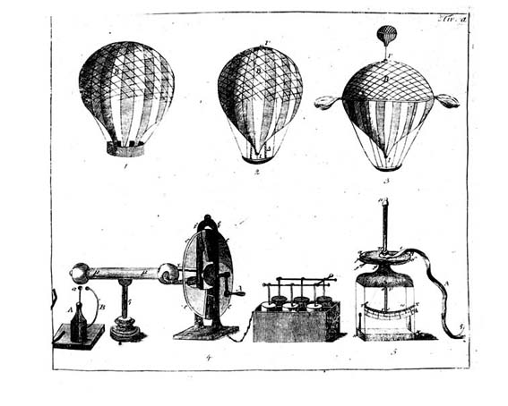
Figure 2
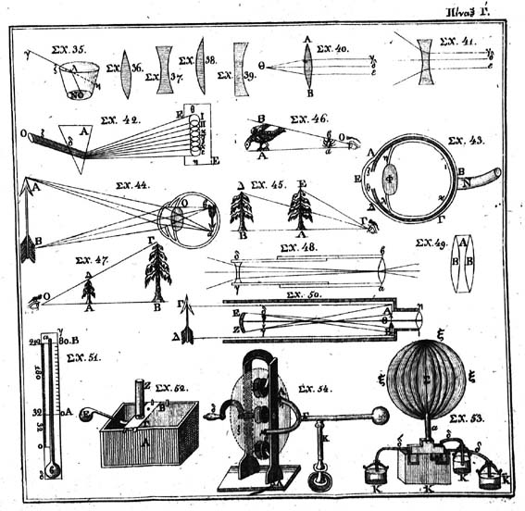
Figure 3

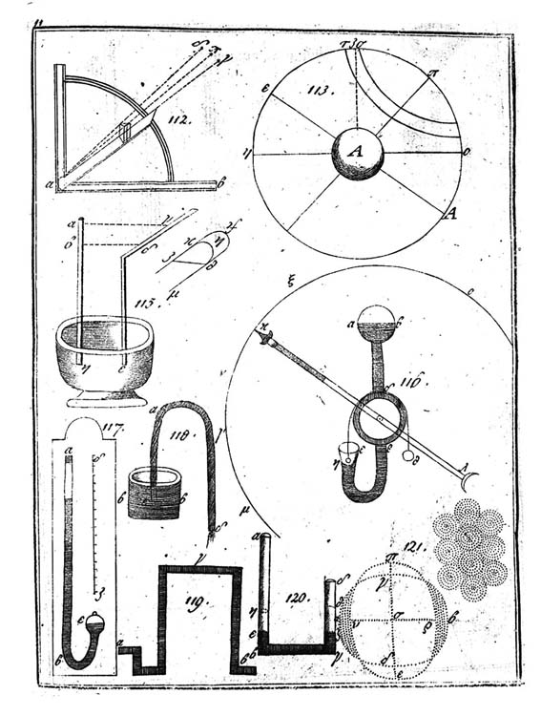
Figure 4
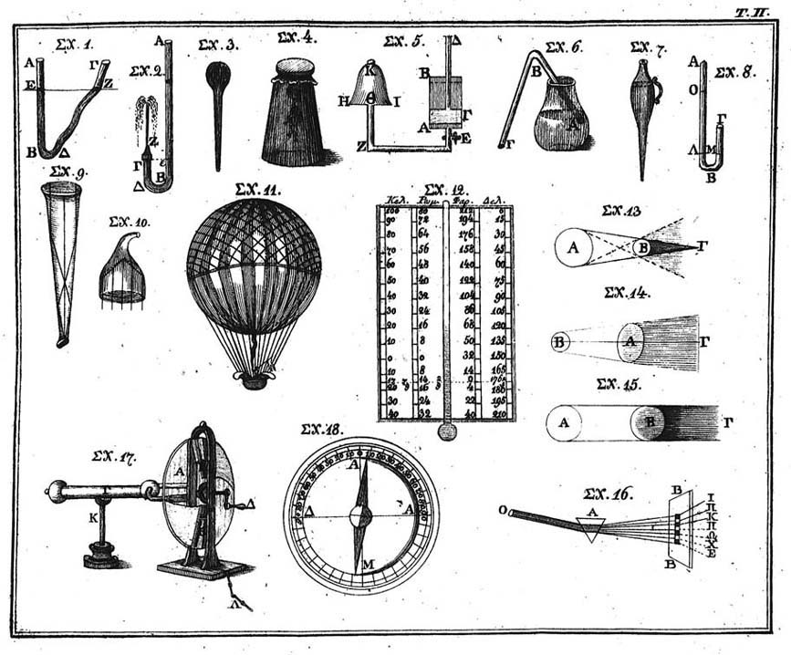

Before taking up the directorship of the Athonias School, Eugenios Voulgaris (1716-1806) was the director of the Maroutsea School of Ioannina (founded in 1742 by Greek merchants of the community of Venice) where he designed a curriculum introducing natural sciences for the first time and also for a short period he was responsible for the school of Kozani (founded in 1745 by the community of Greek merchants living in the region of what is now Hungary). After leaving Athonias School he taught at the Patriarchal Academy in Constantinople and he spent the last years of his life, after 1770, in the Royal Court of Catherine the Great in St. Petersbourg.
Niciforos Theotokis (1731-1800) studied in Padova and Bologna where he worked with Giovanni Poleni and also made astronomical observations with Zanotti. He taught the Physical Sciences in Constantinople, Iasi and Vienna. After the year 1775, he joined Voulgaris in Russia.
Konstantinos Koumas (1777-1836) studied in Vienna. He taught in Smyrna and Constantinople. After the revolution of 1821 he fled to Vienna where he was arrested. After his release he spent most of his time with scientific writing. He acquired a Doctorate from the University of Leipzig and became member of the Academies of Berlin and Munich.
Konstantinos Vardalachos (1775-1830) studied in Padova and Pisa. He taught the Physical Sciences in Bucharest, Chios and Odessa.
Demetrius Darvaris (1757-1833) studied in Vienna, Halle and Leipzig. He taught in Zenum and Vienna.

