Towards a Critical Environmental Education
for Pre-service Elementary Teachers

Αchilleas Mandrikas, Consultant in Primary Education, M. Ed.,
PhD in Environmental Science Education
amandrik@otenet.gr

Constantine Skordoulis, Professor in University of Athens
kostas4skordoulis@gmail.com

University of Athens, Faculty of Primary Education, Laboratory of Didactics & Epistemology of Physical Sciences and Educational Technology
Navarinou13A Athens 10680 Greece

Abstract
This paper presents the content and methodology of an Environmental Education course, taken by pre-service elementary teachers, specifically undergraduate students of the Faculty of Primary Education in the University of Athens, during the winter semesters of 2008-09 and 2009-10. The emphasis is given to the critical approach of the lectures and the supporting methodological choices. The critical dimension of the course is indicated through seven original activities, which pre-service elementary teachers implemented in groups. Then, the critical process adopted is evaluated by pre-service elementary teachers’ judgements.

Introduction
Teacher training in Environmental Education has been recognized as very important by Tbilisi Declaration (UNESCO 1978) and has been reassured by Agenda 21 (UNCED 1992). Moreover, teacher training has been suggested as an independent action in the Decade of Education for Sustainable Development (2005-2014) (UNESCO 2005). According to these proposals, courses concerning Environmental Education and Environmental Science have been introduced by 1990s in the Greek tertiary education, especially in Faculties of Primary Education (Flogaitis 1998, Skordoulis & Sotirakou 2005).

Environmental Education as a Critical Process
Students’ engagement in activities of Environmental Education seeks the fostering of critical thinking, adopting the view that every environmental problem has a hidden societal cause. Critical thinking is not fostered only by observation and record, but mainly by reflection on societal affairs, whereas different values, worldviews, expedience and practices are negotiated. Environmental Education is a radical process with deeply political extensions, in the long run aiming at the fostering of an active citizen, who is able to protest, to demand, to resist and to take action for the protection of the environment (see Flogaitis 2006, p. 201-215).
This dimension of Environmental Education requires to precisely identify ‘who takes the decisions’ in collective life. There is no critical dimension in environmental issues without reference to the social and executive hierarchy, to the self-interest motivation concerning decision making and to the covered by fanfaron declaration expedience. This kind of education requires both an ideological critique of value systems and resistance by concrete decisions and practices. Thus, critical thinking comprises evaluation; choice; search of truth and justice. The students need to continuously ‘sharpen’ their critical thinking ability through the study of complex environmental issues, as they encounter contradicting aspects and values, which have to criticize and towards which have to take position (Schiza 2008).
Tbilisi Declaration taking into account that ‘the environment is a system’ and that ‘the human environment has structure, operation and history’, suggests that countries should ‘develop the systemic approach in analysis and management of physical and human ecosystems’ (UNESCO 1978, p. 20). The systemic approach in Environmental Education constitutes an ideal approach for the teaching of ecological ecosystems, as they are complex self-organized systems. In addition, the systemic approach inevitably takes into account the social, financial and political dimension, as factors could cause injury in such an ecosystem are indicated.

Distinction between Critical Thinking and Critical Pedagogy
Increasingly, countries around the world are promoting forms of ‘critical’ citizenship in the planned curricula of schools. However, the intended meaning behind this term varies markedly and can range from a set of abstract and technical skills under the label ‘critical thinking’ to a desire to encourage engagement, action and political emancipation, often labeled ‘critical pedagogy’ (Johnson & Morris 2010, p. 77). In some contexts citizenship education is also to ensure that citizens are creative and critical. From the citizenship educator’s perspective, this ambiguity opens up the space for the term ‘critical’ to be interpreted from the standpoint of critical pedagogy, which stresses the need for political engagement.
The word ‘critical’ in its educational context can be found in a diverse range of literature where it is given a range of meanings. There is disagreement within the field as to the extent to which critical thinking can go deeper, potentially developing a moralistic (focusing on values) or ideological (focusing on power) concern in students. The term ‘critical pedagogy’ describes that body of literature that aims to provide a means by which the oppressed may begin to reflect more deeply upon their socio-economic circumstances and take action to improve the status quo. Recent manifestations have been variously termed ‘radical pedagogy’, ‘liberatory pedagogy’, ‘revolutionary pedagogy’, ‘oppositional pedagogy’ and ‘border pedagogy’ (Green 1997; Giroux 2003; Hill 2003; De Lissovoy and McLaren 2006; Au 2007).
We think that critical thinking and critical pedagogy have some common points, as seen in Figure 1: skills of reasoning and judgment, dialogue or argument and the discovery of new knowledge.

Figure 1. Intersections between critical thinking and critical pedagogy
(Johnson & Morris 2010, p. 80).
These are the first steps towards critical pedagogy, as they emerge the ideological/moral, the collective/social, the subjective/context-driven, and the praxis (reflective action) dimensions.
From the perspective of critical pedagogues, the critical-democratic citizen and the justice-oriented citizen are the ideal types, as their defining features include a concern for social justice and a desire to improve society. The foundational elements of this model describe a balance of desirable attributes for the ideal citizen, including: a sense of identity; the enjoyment of certain rights; the fulfillment of corresponding obligations; a degree of interest in public affairs; and an acceptance of basic societal values (Cogan & Derricott 1998, p. 2–3)
In recent years, Environmental Education is considered a part of contemporary citizenship. The term ‘citizenship education’ is often characterized as the ideal out of the various terminologies used to describe social or political education. Kerr expands his model to characterize three types: ‘Education ABOUT Citizenship… Education THROUGH Citizenship… Education FOR Citizenship’ (Kerr 2000, p. 210). Similarities with Environmental Education types are obvious: ‘Education ABOUT Environment… Education IN Environment…Education FOR Environment’ (Lucas, 1980). We believe that the creation of a critical-democratic citizen fully expresses the aims of critical pedagogy, which requires some cooperative skills, a pure concern for social justice and motivation to change society. If Environmental Education improves students’ skills of reasoning and judgment, fosters students’ competence of argumentation and guides to the discovery of new knowledge, then is the best way to access and establish critical pedagogy.

A framework for critical environmental education
Several frameworks for environmental or citizenship education already possess an explicitly critical angle. MacPherson (2005) suggests a program for global ecological citizenship education based on a renewed global form of liberal education; ecological values and ethics; interdisciplinary inquiry; and reflexive practice within pedagogy of compassion. Hutchison argues that “the holistic philosophy is judged to provide the best educational context for dealing with the environmental challenges we face” (Hutchinson 1998, p. 56). This radical egalitarian vision might be supported through (see for more MacPherson 2005, p. 143-154):
- an expanded interpretation of liberal education, underpinning the idea that all human beings share certain rights or capabilities, that every citizen of the world should have the opportunity to develop
- global ecological citizenship, an emerging view of citizenship that emphasizes participatory and active democratic education and engagement
- establishing ecologically consistent values and ethics, including the “equality” of human and non-human beings in an ecosystem, a radically new conception of equity that challenge even the deepest anthropocentric biases of humanity
- supporting enhanced interdisciplinarity, as there is a need to expand these studies across the curriculum, to include more relationship-oriented, ecological studies of geography, health, culture, and language arts at all grade levels
- encouraging more reflexive and more compassionate pedagogical practices, in order to stimulate such critical reflection and practice.
The drive to equip students with an understanding of science in its social, cultural, economic and political contexts is, of course, the underpinning rationale of the so-called science-technology-society (STS) approach – more recently expanded to STSE (where E stands for environment) (Hodson 2009, p. 2). According to Hodson (2009) the kind of issues-based approach can be regarded as comprising four levels of sophistication:
- Level 1: Appreciating the social impact of scientific and technological change, and recognizing that science and technology are, in substantial measure, culturally determined.
- Level 2: Recognizing that scientific and technological development is inextricably linked with the distribution of wealth and power.
- Level 3: Developing one's own views and establishing one's own underlying value positions.
- Level 4: Preparing for and taking action on socioscientific and environmental issues.
Finally, Jensen (2002) has developed a useful framework that categorizes the knowledge that informs and promotes pro-environmental behavior and other forms of action in terms of four dimensions: (i) knowledge about the environmental issue/problem – principally, its nature and extent, and the scientific and technological knowledge relevant to it; (ii) knowledge about the underlying social, political and economic structures, and how they contribute to creating particular environmental problems; (iii) knowledge about how to bring about changes in society through direct or indirect pro-environmental behavior; (iv) knowledge about the likely outcome or direction of possible changes (Hodson 2009, p. 8).

Educational design of Environmental Education in a critical overview
Adopting the aspects mentioned above, the Environmental Education course in the Faculty of Primary Education in University of Athens is comprised by four theoretical, four methodological and five practical lectures.
Into the first part of the course, some basic theoretical lectures were considered necessary, so as students could define the historical, philosophical and educational frame into which Environmental Education matured:
- Introduction – Educational material of Environmental Education
- History of Environmental Education: precursor educational movements, environmental movement, international conferences, important texts
- Definition of Environmental Education – Aim and targets – Basic characteristics and principles – Sustainable development
- Environmental Ethics and Education – Anthropocentrism – Biocentrism, Deep Ecology, Eco-Philosophy, Social Ecology, Eco-Feminism, Eco-Socialism
The second part of the course consists of methodological elements and educational strategies used in Environmental Education:
- Methodology of Environmental Education: Project method – Problem solving method – Partial educational strategies
- Environmental Education in Greece – Constitution (Centers of Environmental Education, Local Director of Environmental Education, Nongovernmental Organizations, Hellenic Association of Educators of Environmental Education) – Characteristics of a school program of Environmental Education – Instructions for the implementation of a school program of Environmental Education – Strategies for incorporation Environmental Education in educational system
- Systemic approach – Design of a school program on ENERGY
- Critical thinking approach – Design of a school program on URBAN FOREST

The third part of the course was absolutely practical including the design of a school program of Environmental Education by the pre-service elementary teachers and the presentation of fully implemented school programs:
- Design of a school program on WATER based on Project Method
- Design of a school program on WASTE based on Problem Solving Method
- Presentation of implemented school programs of Environmental Education
- Practice on partial educational strategies (role playing, concept maps, brainstorming, survey)
- Environmental information via Internet (sites and portals of Environmental Education, national programs and networks of Environmental Education, international programs, nongovernmental organizations etc)
The critical overview concerned not only the content of the lectures, but also the methodology of the course. The main methodological choice was the abolition of the traditional lecture and the ‘fracturing’ of the theory in small pieces, which were embedded by activities in groups. After presenting 4-5 slides about a topic, the pre-service elementary teachers were asked to implement in groups a critical activity referred to the topic just presented. By this choice, the theory was directly transformed to educational praxis with a critical approach. As the most important, we consider that the pre-service elementary teachers experience themselves this kind of transformation.

Activities implementing critical thinking
In this section we present some activities used in the course through which critical thinking is fostered. Sustainability is nowadays to the point of the discussion concerning education for the environment. In order to access this concept, we have designed three concrete activities:

Α. The spiral of poverty
The following figure and some terms are given to the pre-service elementary teachers, in order to be placed in concrete positions indicating causal relations. The terms to be placed in three circles are: ‘environment degradation’, ‘overpopulation’, ‘poverty’. The terms to be placed in linked arrows are: ‘land reclamation for agriculture’, ‘ground wilderness’, ‘increasing childbirth for more workers’, ‘lack of natural resources’, ‘urbanization’, ‘lack of education’. The pre-service elementary teachers have to work in groups, to argue, to synthesize different aspects, to decide a common placement of the terms and to justify their choices.
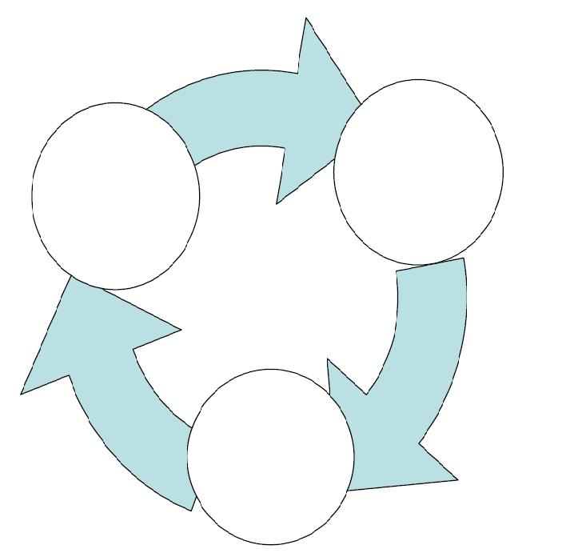

Figure 1: The spiral of poverty

Β. Α sustainable decision
A problem accompanied by ten different solutions is provided. The pre-service elementary teachers are asked to answer after evaluating the advantages and disadvantages of each solution.
‘John is a doctor; he lives and works in Athens. He inherited an old house at the grandparents’ village which lies on Pindos Mountain and has 200 of inhabitants today. John wants to use the house. Which of the following choices are compatible with sustainable development of the village? Which is the best in your opinion?’
- To sell the house to immigrants who have the ambition to return and stay permanently at the village.
- To repair the house and become a permanent inhabitant.
- To transform the house into a traditional hostel, in this way increasing occupation and enforcing local economy.
- To concede the house in order to be used as a folklore museum, which already is to take his name.
- To demolish the house, because it is dangerous in its present condition, and to built a modern bioclimatic house.
- To demolish the house, in order to rent the available place for agriculture.
- To concede the house to Local Authorities for building a school.
- To demolish the house and build a great modern apartment hotel.
- To transform the house into a health center, which is needed at the village, and to live as a doctor there.
- To sell the house to a company in order to build a modern conference center, whereas medical conferences will be periodically organized.

C. Contradicting aspects – debate
The following problem containing obviously contradicting aspects is provided. The pre-service elementary teachers are asked to be divided in groups supporting their opinion by arguments in a debate. Then, they can also organize a role playing.
‘A power plant using anthracite is designed to be built in a village near the sea. The inhabitants of the region have different opinions’:

Figure 2: Positive opinions about the power plant
Figure 3: Negative opinions about the power plant

In order to better understand the different approach between Anthropocentrism and Biocentrism we have designed two other activities:

D. Find the implying philosophy
A series of questions and different corresponding answers are provided. The pre-service elementary teachers working in groups are asked to find out which of them represent or imply Antropocentrism and which ones Biocentrism. For example:

‘Is it fair to kill bugs?’

- Yes, because they transfer viruses to humankind.
- No, because they do not hurt humankind.
- No, they have also rights.
- No, because they have appeared on earth before humankind.
- No, because humankind has not the authority to take any kind of life.
- No, because they also play a role in ecosystems equilibrium.
- Yes, they reproduce rapidly, so worry of disappearance does not exist.
- Yes, I hate them!
- No, they are so fragile!
- Yes, they offer nothing at all to nature.

Ε. Find answers according to Antropocentrism and Biocentrism
A series of various questions concerning environmental issues is provided. The pre-service elementary teachers working in groups are asked to give two kinds of answers in every question, one based on Antropocentrism and the other based on Biocentrism approach:

- Why nomination of ‘protected areas’ is useful?
- Who cares about whales disappearing?
- What is your opinion about using pesticides in agriculture?
- Is wastewater treatment necessary?
- What is your opinion for hunting?
- Why throwing plastic waste into the sea is forbidden?
- What is the damage caused by forest fires?
- Why “Sea Diamond” shipwreck pulling up is important for Santorin island?

For better understanding relations between different domains in environmental issues, we have created and used two other activities. Through these activities, intedisciplinarity and systemic approach become more understandable. As the most appropriate subject, we have chosen ‘Energy’:

F. Thematic analysis
An empty concept map in spider form and main subject ‘Energy’ is provided. The pre-service elementary teachers working in groups are asked to suggest components – domain science through which they would study ‘Energy’ alongside their students. No concrete terms are given, but an indicative expected thematic analysis is shown in Figure 4:
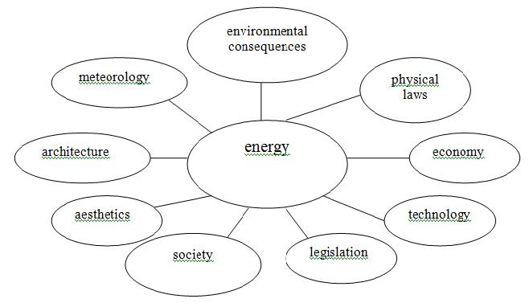

Figure 4: An indicative thematic analysis of ‘Energy’

G. Systemic analysis
Another empty concept map in spider form is provided (Figure 5). The pre-service elementary teachers are asked to suppose that they implement a school program of Environmental Education named ‘Energy saving in our school’. In correspondence with anterior thematic analysis, they are asked to precisely define which factors and parameters they will research for a complete study of the subject and to write them on the concept map. Then, they are asked to nock arrows indicating causing relations between these factors.

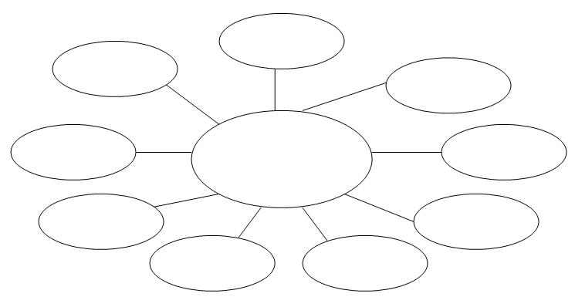

Figure 5: A concept map for systemic analysis of a school program of Environmental Education named ‘Energy saving in our school’

In the case of trouble or time limitation, we also provide concrete terms and we ask for placement on the concept map indicating systemic analysis: ‘weather’, ‘photovoltaic’, ‘electric energy’, ‘budget’, ‘maintenance of building rules’, ‘orientation’, ‘local makings’, ‘consumption’, ‘wall heat insulation’, ‘reduction of air pollutants’, ‘traditional settlement’, ‘climate’, ‘roof by tile’, ‘social interest’, ‘microclimate’, ‘sunshade’, ‘double sheet glass’, ‘inhabitants’ practices’, ‘solar heater’, ‘conduction’, ‘financing’, ‘environmental ethos’, ‘keeping cleanness’, ‘colors’, ‘local tradition’, ‘expenditure’, ‘heat’, ‘keeping rules of school operation’, ‘solar collector’, ‘plant trees’.

Results and discussion
We think that the most accurate evaluation of our critical approach through such collective educational activities is derived from the pre-service elementary teachers who implemented the activities. For this purpose, we gave an open-ended, anonymous questionnaire to 25 pre-service elementary teachers, who had attended the whole lectures during 2008-09 and 2009-10. Their answers were categorized using semantic content analysis. In addition, 8 semi-structured interviews of volunteers pre-service elementary teachers were taken.

96% of the pre-service elementary teachers declared that the course corresponded to their expectation. In response to the question ‘What is the positive point of the course?’ 44% underlined the practical character and 40% the pleasant ‘atmosphere’ of working inside groups. When working in groups they discussed; they constructed arguments; they demystified disagreement; and they fostered critical thinking, in order to face a problem provided in the form of collective activity. 36% of the pre-service elementary teachers gave positive points to both the experience activities and to the scientific knowledge concerning various environmental issues. As ‘experience activities’ they defined the seven activities mentioned above, and also the debate, the role playing and a field trip in the center of the city, during which they learnt not only to ‘see’ but also to ‘observe’.

In response to the question ‘Which of the elements of the course do you consider more useful in implementing a school program of Environmental Education?’ 36% referred methodological elements, like the Project Method, working in small groups, the presentation of implemented school programs and use of educational material. 32% reported as very important the seven activities described above, because they had sharpened their critical thinking and they had extended their way of thought. This improvement is traceable into the answers of the same question. Despite their little experience in Environmental Education, the pre-service elementary teachers considered very useful the target determination, the participation of the whole class in the selection of the subject, the field trip, the time schedule and teachers’ susceptibility.

In response to the question ‘How has the course affected you in personal level?’33% declared an immediate effect and modification of everyday life attitudes, such as water saving, energy saving, recycling and reduction of consumption. 50% declared a mediate effect, such as desire for more information, desire for action, special interest about urban forests, becoming conscious of sustainability, preference of prevention against repression and ascertainment of complexity in environmental issues. Two pre-service elementary teachers clearly declared that they began to collect articles and other leaflet for future use in the class, exactly as they have seen into the course. Another one said that he fostered his ability to observe his surroundings and to be conscious of the complex implying relations between its elements.
Although the number of the sample is small, we think that pre-service elementary teachers’ answers clearly show the attribution of the course to the improvement of critical thinking in perspective of critical pedagogy engagement.

Conclusions and Teaching implications
It is our opinion that these findings show that pre-service elementary teachers’ judgments concerning ‘Environmental Education’ course they had attended were favorable, thus justifying our methodological choices. The critical approach seems to be well experienced, as long as pre-service elementary teachers disentangle its characteristics and evaluate them positively. So, it is our belief that Environmental Education can effectually acquire a critical overview, when based on appropriate activities. Finally, we believe that our course suggests that the critical approach can be one of Environmental Education main discernible features.

REFERENCES
Au, W. (2007). Epistemology of the oppressed: The dialectics of Paulo Freire’s theory of knowledge. Journal for Critical Education Policy Studies, 5, 2. Available online at: http://www.jceps.com/?pageIDΌarticle&articleIDΌ100
Cogan, J.J. & Derricott R. (1998). Citizenship for the 21st century: An international
perspective on education. London: Kogan Page.
De Lissovoy, N. & McLaren P. (2006). Ghosts in the procedure: Notes on teaching and subjectivity in a new era. In The practical critical educator: Critical inquiry and educational practice, ed. K. Cooper, and R. White, 151-165. Dordrecht: Springer.
Flogaitis E. (1998). Environmental Education. Ellinika Grammata. Athens (in Greek)
Flogaitis Ε. (2006). Education for the Environment and Sustainability. Ellinika Grammata. Athens (in Greek)
Giroux, H.A. (2003). Critical theory and educational practice. In The critical pedagogy reader, ed. A. Darder, M. Baltodano, and R.D. Torres, 27–56. New York and London: Routledge Falmer
Green, A. (1997). Postmodernism and state education. In Education, globalization and the nation state, ed. A. Green. Basingstoke: Macmillan
Hill, D. (2003). Global neo-liberalism, the deformation of education and resistance.
Hodson, D. (2009). Putting Your Money Where Your Mouth Is: Towards an Action-oriented Science Curriculum. Journal for Activist Science & Technology Education, 1, 1, p. 1-15
Hutchison, D. (1998). Growing up green: Education for ecological renewal. NY: Teachers College Press.
Jensen, B.B. (2002) Knowledge, action and pro-environmental behaviour. Environmental Education Research, 8, 3, 325-334.
Journal for Critical Education Policy Studies, 1, 1. Available online at: http://www.jceps.com/?pageIDΌarticle&articleIDΌ7
Johnson L. & Morris P. (2010), Towards a framework for critical citizenship education, Curriculum Journal, 21, 1, 77-96
Kerr, D. (2000). Citizenship education: An international comparison. In Education for
citizenship, ed. D. Lawton, J. Cairns, and R. Gardner, 200-227. London: Continuum.
Lucas A. M. (1980), Science and environmental education: Pious hopes, self praise and disciplinary chauvinism, Studies in Science Education, 7, 1-26
MacPherson S. (2005), Educating Ecological Citizens of The Blue Planet, Canadian Journal of Environmental Education, 10, 141-156
Schiza Κ. (2008). Systemic thought and Environmental Education. C. Ε. Dardanos. Athens (in Greek)
Skordoulis C. & Sotirakou Μ. (2005). Environment: Science and Education. Leader Books. Athens (in Greek)
UNCED (United Nations Conference on Environment and Development) (1992). Agenda 21. Rio de Janeiro (3-14 June), Brazil
UNESCO (1978). The Final Report: International Conference on Environmental Education, Tbilisi (14-26 October), ED/MD/49, Paris.
UNESCO (2005). UN Decade of Education for Sustainable Development 2005-2014, Draft International Implementation Scheme, Paris, ED/2005/PI/H/1.

